EDUCATIONAL QUALIFICATION

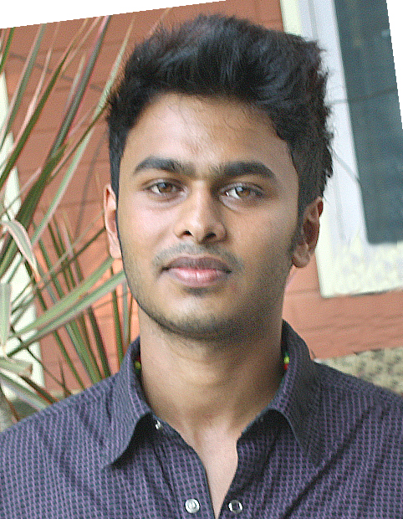

PERSONAL INFORMATION
Name: Rohith R Mangattu
Sex: Male
Date of Birth: 30/04/1994
Father’s name: Rajan Joseph
Place of birth: Aluva, Ernakulam
Address: Mangattu (H) Anakkara Po, Idukki
Email: rohithmangattu@rocketmail.com
Phone: 08089155338

OBJECTIVE
To purse a rewarding career in a dynamic environment where I can enhance my personal as well as technical skills.

Completed 10th in Montfort School, Anakkara (March 09’ –April 10’) - Percentage – 66%

Completed 12th Science in Ossanam School, Kattapana (March 11’ – April 12’) – Percentage – 70%

Completed Mechanical Engineering Diploma in Ninans Polytechnic College, Kottayam (September12’ – June 15’) – percentage – 69%

EXPERIENCE
- Completed Internship at Kelachandra Machines, Kottayam (April 15’ – May 15’) .The internship was served in the Machine Fabrication Shop. During this period I had the opportunity to work on welding fabrication, fitting and assembly work of rubber processing machinery manufactured by Kelachandra group.
- Completed Project at Common Facility Service Centre (GOVERNMENT OF KERALA) (23 Jan 15’-06 Feb 15’). The project work on “Die for Rubber Testing”.
- Worked at Engineering Department of Indian Oil Corporation Limited, GOA Divisional Office on behalf of Rahul Construction (03 Oct 15’- 10 Oct 16’).
ACHIEVEMENTS
- Participated twice in marathon race (17 km) for the cause environmental protection (completed successfully).
- Participated in All Kerala State Inter District Table Tennis Championship 2013.
- Achieved 1st position Youth category and 2nd in Men’s category conducted by Don Bosco Table tennis championship table (06 Oct’12).
- Achieved 3rd position in All Kerala CBSE school championship table tennis tournament (22 Oct’05).
- Achieved 4th position in All Kerala State school championship table tennis tournament (25 Nov’12).
- Achieved Outstanding Achievement of the year in table tennis by YMCA KOTTAYAM in 2013 as well as 2014.

INTERESTS

- Hobbies - Listening to music, play table tennis, pencil drawing, exploring new places.

- Job Related Interest – Technical Designing, Designing, Customer care support, Social Service.

SKILLS

- Languages Known – Proficient in English and Malayalam, Tamil, Hindi
- Computer skills- Basic Computer Skills, Microsoft office, Photoshop, AutoCad.
- Personal skills - Good Interpersonal Communication, Team work, Leadership, stress management.

